1. Introduction (VM DETAILS)

1.1 Purpose
This document captures the detailed configuration, resource allocation, and current operating state of the virtual machines (VMs) that make up the CFS (Customer Facing Service) and RFS (Resource Facing Service) environment.
This document covers seven (7) virtual machines across two environments:
- New Instance — cfsleader, rfsleader1, rfsleader2, rfsleader3
- Old Instance — CFS, RFS Primary (TFDCCISNSRFS1), RFS Standby (RFS1-STBY)
For each VM, the document records hostname/IP mapping, CPU configuration, memory (RAM) utilization, disk utilization, operating system details, and system uptime, backed by terminal screenshots captured at the time of assessment.

1.3 Definitions & Abbreviations
CFS | Customer Facing Service
RFS | Resource Facing Service
VM | Virtual Machine
OS | Operating System
RAM | Random Access Memory
CPU | Central Processing Unit
STBY | Standby
Buff/Cache | Memory used by the OS for buffers and page cache

2. Infrastructure Overview
The environment is split into a New Instance cluster (Ubuntu 24.04.4 LTS, VMware-hosted) consisting of one CFS leader node and three RFS leader nodes, and an Old Instance set (Ubuntu 20.04.x LTS, VMware-hosted) consisting of a legacy CFS node, an RFS primary node, and an RFS standby node.

2.1 New Instance — VM Summary
VM Name (Hostname) | IP Address | CPU Count | RAM Capacity | Total Disk | Disk Utilization
cfsleader | 172.28.2.17 | 8 | 16 GB | 97 G | 29%
rfsleader1 | 172.28.2.18 | 16 | 33 GB | 195 G | 30%
rfsleader2 | 172.28.2.19 | 16 | 33 GB | 195 G | 17%
rfsleader3 | 172.28.2.20 | 16 | 33 GB | 195 G | 16%

Note: RAM Capacity above reflects total capacity as reported at the OS level; per-VM "Available RAM" figures are detailed in Section 3.

2.2 Old Instance — VM Summary
VM Name (Hostname) | IP Address | CPU Count | RAM Capacity | Total Disk | Disk Utilization
CFS | 172.28.2.150 | 8 | 48 GB | 49 GB | 40%
TFDCCISNSRFS1 (RFS Primary) | 172.28.2.110 / .133 | 8 | 32 GB | 97 GB | 47%
RFS1-STBY (RFS Standby) | 172.28.2.119 | 8 | 32 GB | 49 GB | 96%

3. New Instance — Detailed VM Specifications

3.1 CFS VM — cfsleader (172.28.2.17)
Customer Facing Service leader node

Host Information
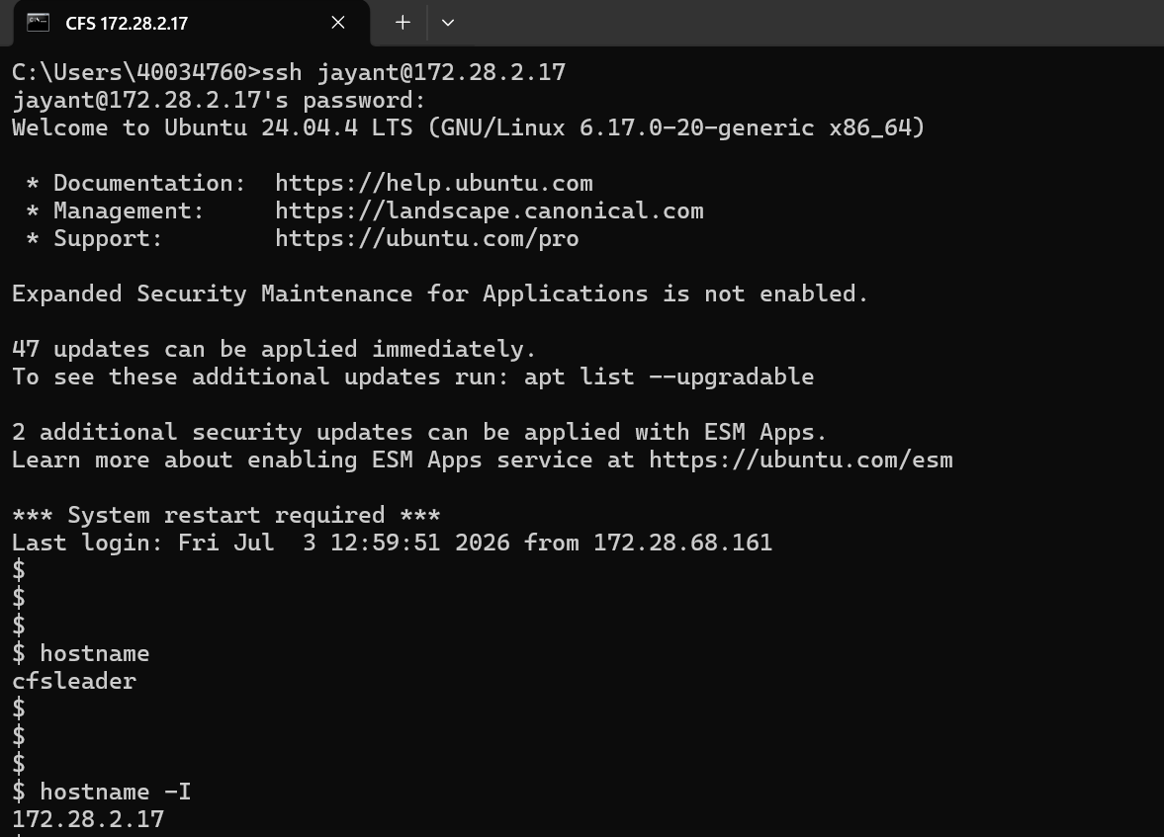
Screenshot — Hostname & IP Address
Hostname | cfsleader
IP Address | 172.28.2.17
Operating System | Ubuntu 24.04.4 LTS (Noble Numbat)
Kernel | Linux 6.17.0-20-generic
OS Family | Debian-based Linux

CPU Details
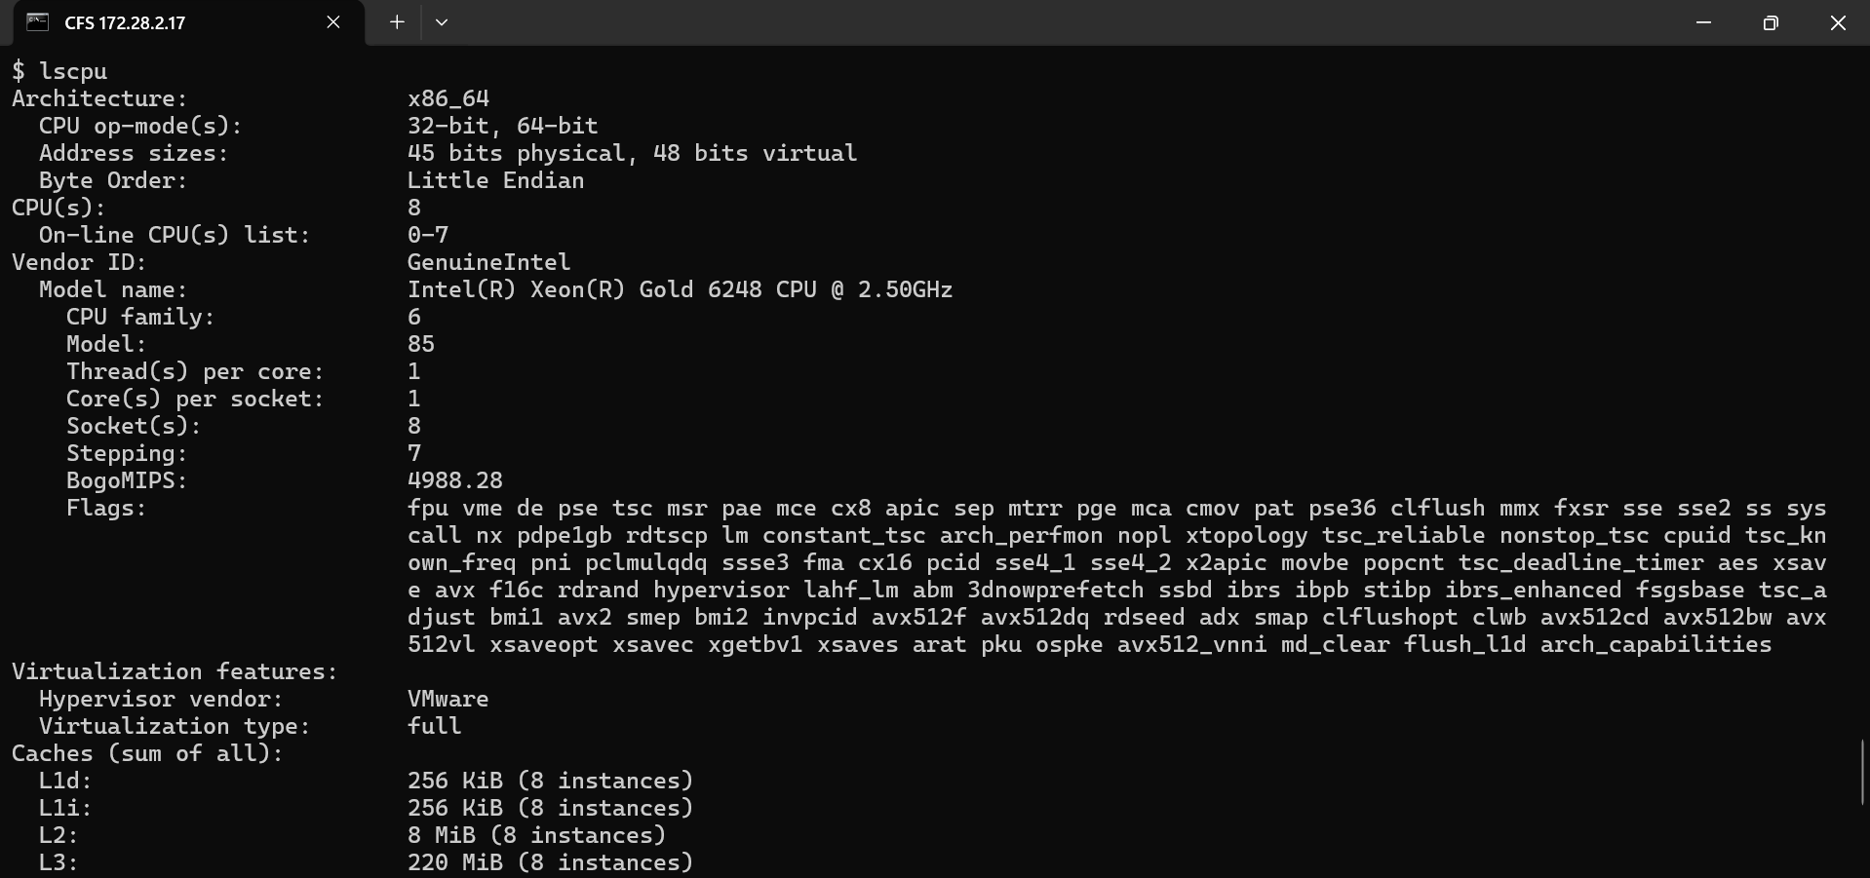
Screenshot — CPU Details
CPU Count | 8
Architecture | x86_64
Processor | Intel(R) Xeon(R) Gold 6248 CPU @ 2.50GHz
Hypervisor | VMware
Virtualization Type | Full

Memory (RAM) Details
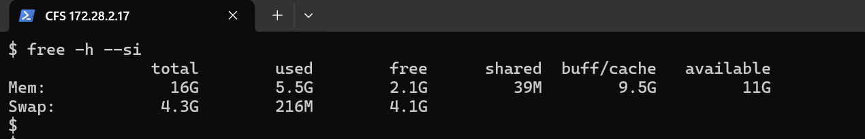
Screenshot — RAM Details
Total RAM | 16 GB
Used RAM | 5.5 GB
Free RAM | 2.1 GB
Available RAM | 11 GB
Buff/Cache | 9.5 GB
Swap Total | 4.3 GB
Swap Used | 216 MB
Swap Free | 4.1 GB

Disk Details
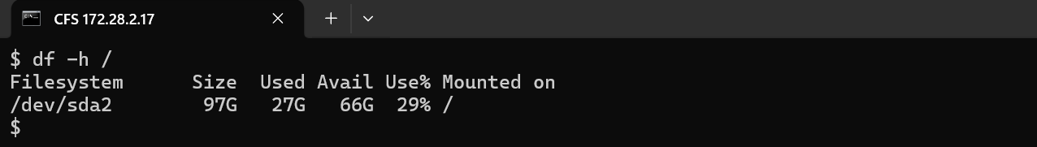
Screenshot — Disk Details
Total Disk Space | 97 G
Used Disk Space | 27 G
Available Disk Space | 66 G
Disk Utilization | 29%
Filesystem | /dev/sda2
Mount Point | /

Operating System Details
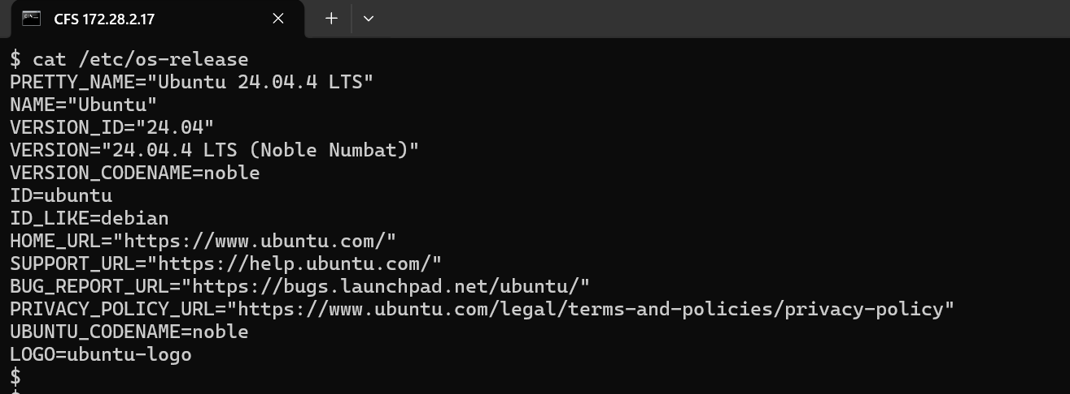
Screenshot — /etc/os-release
Operating System | Ubuntu 24.04.4 LTS
Version | 24.04.4 LTS (Noble Numbat)
Architecture | x86_64
OS Family | Debian-based Linux

System Uptime
Screenshot — System Uptime
Server Uptime | 84 Days 18 Hours 27 Minutes
Logged-in Users | 6
Load Average (1 min) | 0.02
Load Average (5 min) | 0.02
Load Average (15 min) | 0.00

3.2 RFS-1 VM — rfsleader1 (172.28.2.18)
Resource Facing Service leader node 1
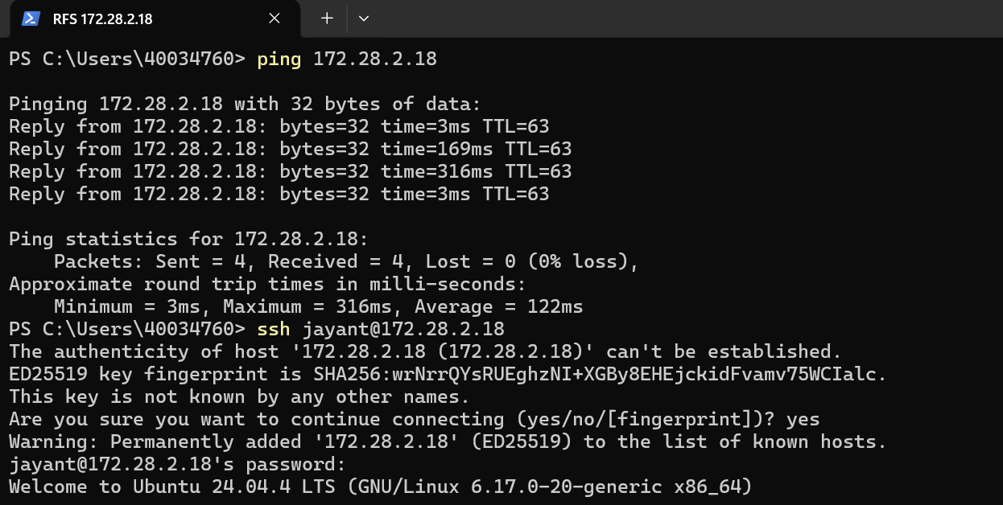
Screenshot — System Overview

Host Information
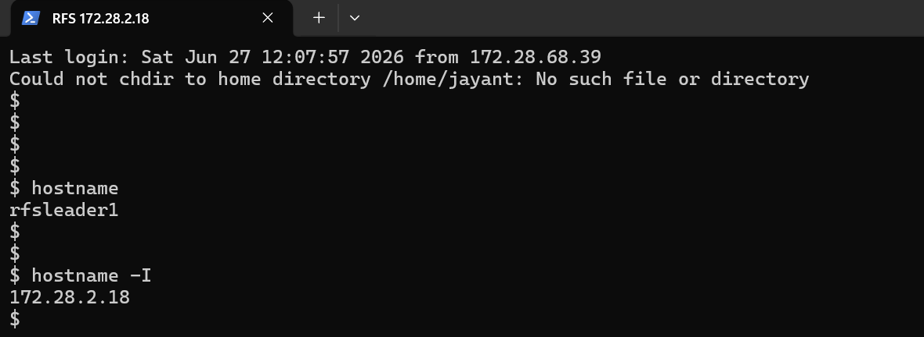
Screenshot — Hostname & IP Address
Hostname | rfsleader1
IP Address | 172.28.2.18
Operating System | Ubuntu 24.04.4 LTS (Noble Numbat)
OS Family | Debian-based Linux

CPU Details
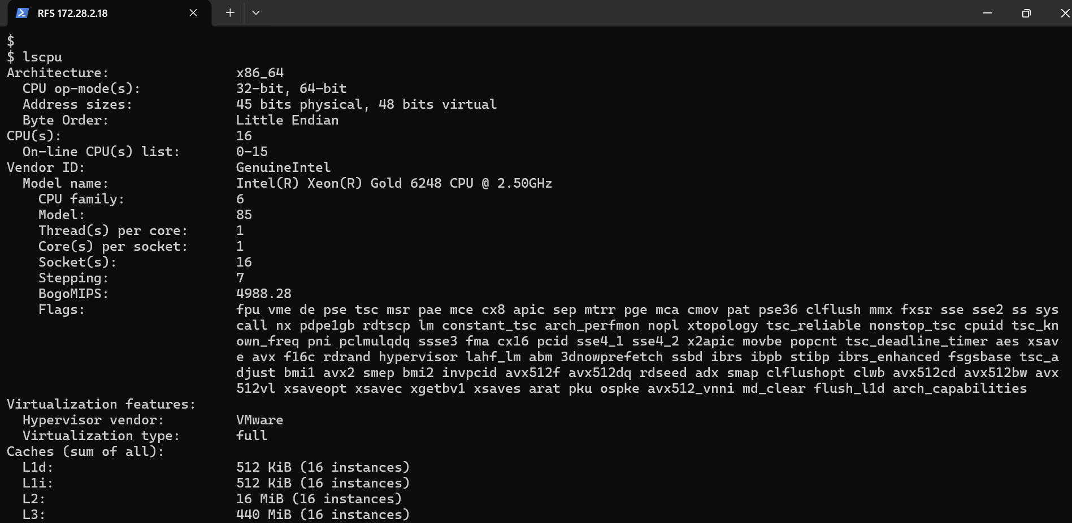
Screenshot — CPU Details
CPU Count | 16
Architecture | x86_64
Processor | Intel(R) Xeon(R) Gold 6248 CPU @ 2.50GHz
Hypervisor | VMware
Virtualization Type | Full

Memory (RAM) Details

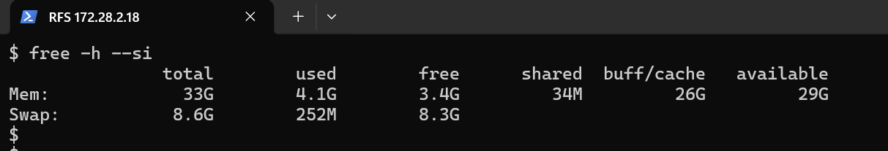
Screenshot — RAM Details
Total RAM | 33 GB
Used RAM | 4.1 GB
Free RAM | 3.4 GB
Available RAM | 29 GB
Buff/Cache | 26 GB
Swap Total | 8.6 GB
Swap Used | 252 MB
Swap Free | 8.3 GB

Disk Details
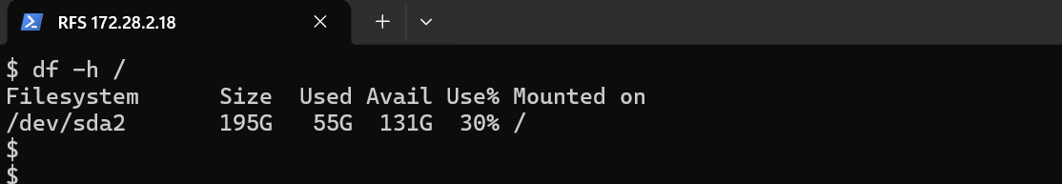
Screenshot — Disk Details
Total Disk Space | 195 G
Used Disk Space | 55 G
Available Disk Space | 131 G
Disk Utilization | 30%
Filesystem | /dev/sda2
Mount Point | /

Operating System Details
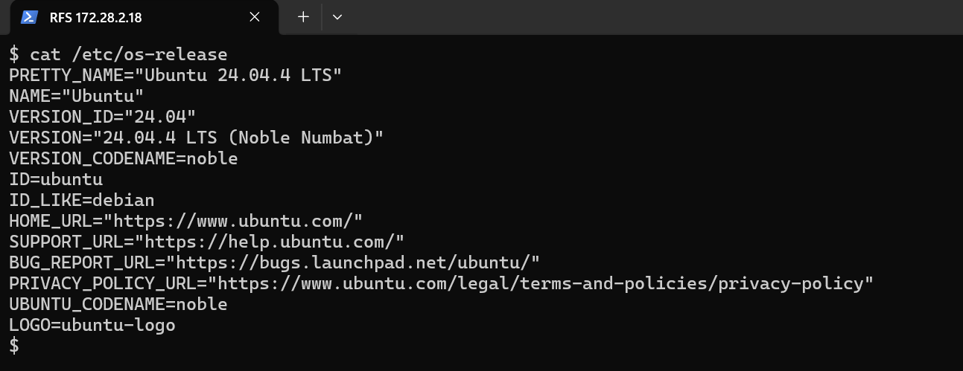
Screenshot — /etc/os-release
Operating System | Ubuntu 24.04.4 LTS
Version | 24.04.4 LTS (Noble Numbat)
Architecture | x86_64
OS Family | Debian-based Linux

System Uptime
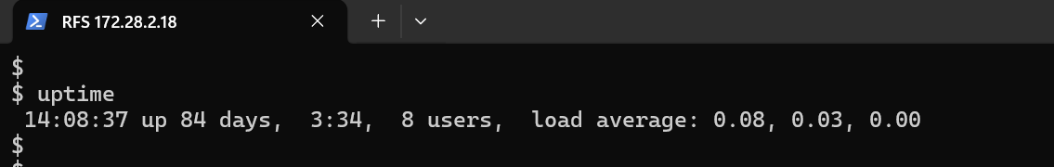
Screenshot — System Uptime
Server Uptime | 84 Days 3 Hours 34 Minutes
Logged-in Users | 8
Load Average (1 min) | 0.08
Load Average (5 min) | 0.03
Load Average (15 min) | 0.00

3.3 RFS-2 VM — rfsleader2 (172.28.2.19)
Resource Facing Service leader node 2
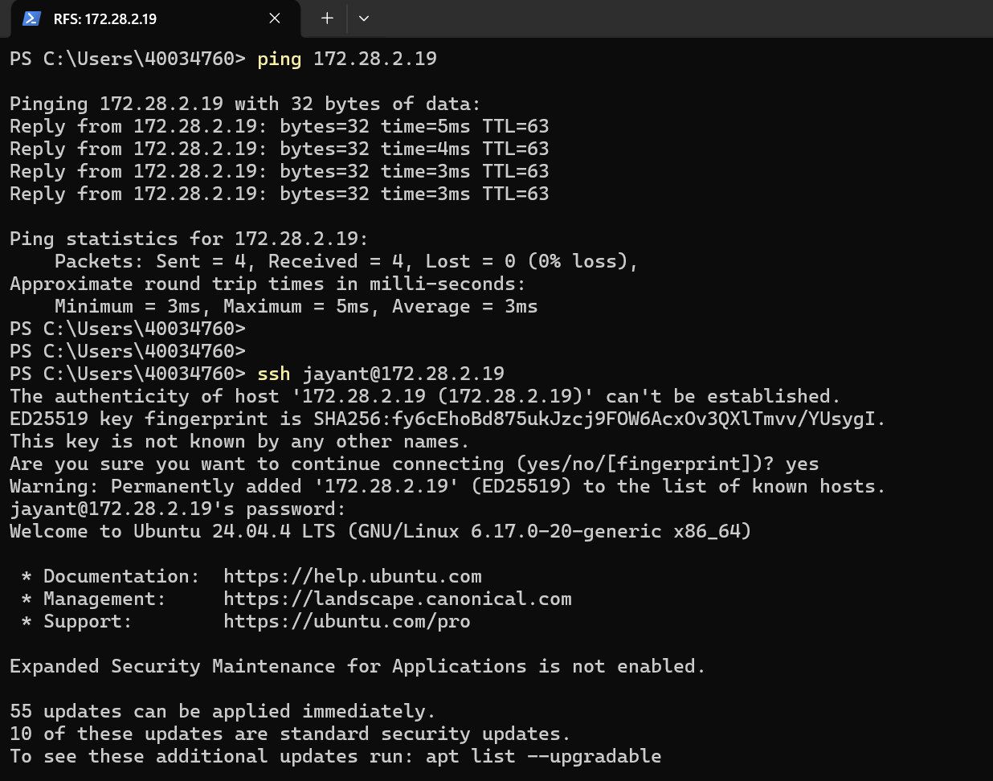
Screenshot — System Overview

Host Information
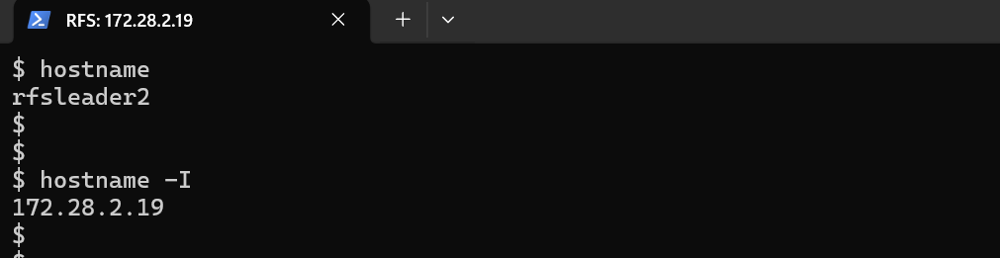
Screenshot — Hostname & IP Address
Hostname | rfsleader2
IP Address | 172.28.2.19
Operating System | Ubuntu 24.04.4 LTS (Noble Numbat)
OS Family | Debian-based Linux

CPU Details
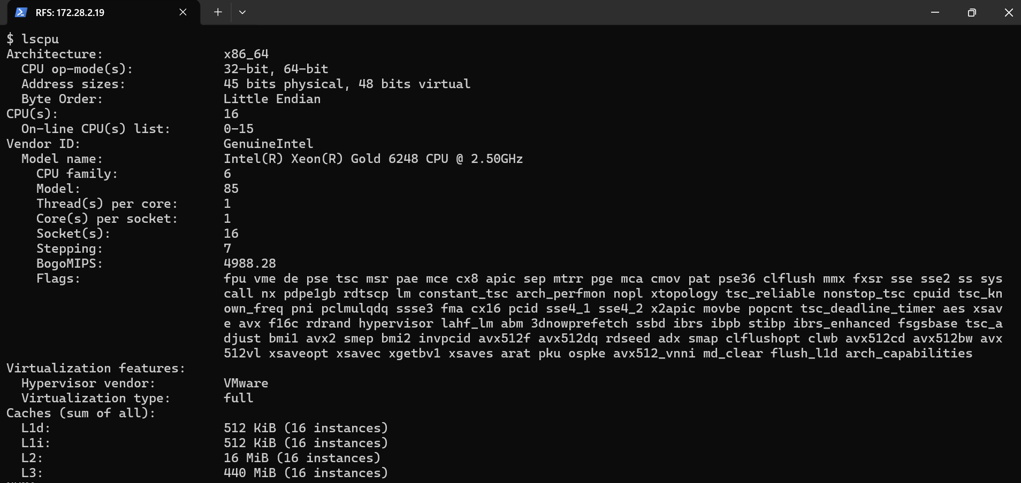
Screenshot — CPU Details
CPU Count | 16
Architecture | x86_64
Processor | Intel(R) Xeon(R) Gold 6248 CPU @ 2.50GHz
Hypervisor | VMware
Virtualization Type | Full

Memory (RAM) Details

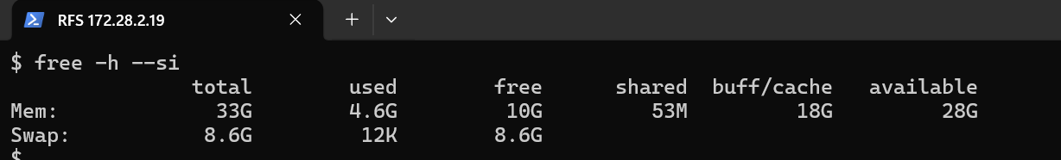
Screenshot — RAM Details
Total RAM | 33 GB
Used RAM | 4.6 GB
Free RAM | 10 GB
Available RAM | 28 GB
Buff/Cache | 18 GB
Swap Total | 8.6 GB
Swap Used | 12 KB
Swap Free | 8.6 GB

Disk Details
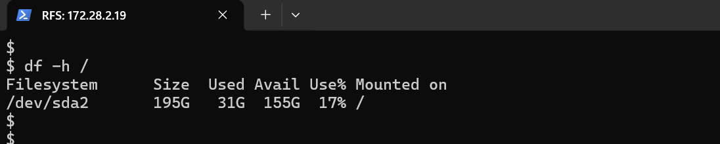
Screenshot — Disk Details
Total Disk Space | 195 G
Used Disk Space | 31 G
Available Disk Space | 155 G
Disk Utilization | 17%
Filesystem | /dev/sda2
Mount Point | /

Operating System Details
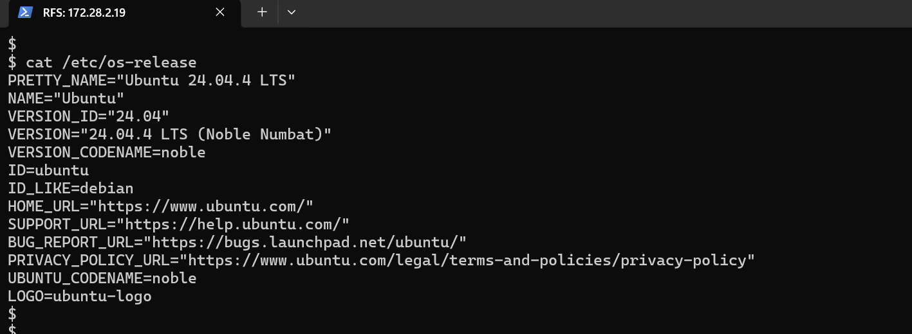
Screenshot — /etc/os-release
Operating System | Ubuntu 24.04.4 LTS
Version | 24.04.4 LTS (Noble Numbat)
Architecture | x86_64
OS Family | Debian-based Linux

System Uptime
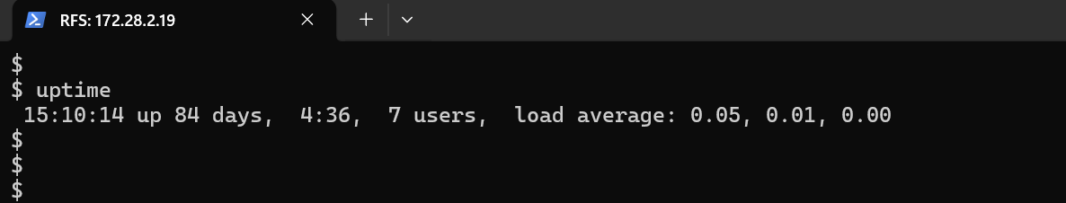
Screenshot — System Uptime
Server Uptime | 84 Days 4 Hours 36 Minutes
Logged-in Users | 7
Load Average (1 min) | 0.05
Load Average (5 min) | 0.01
Load Average (15 min) | 0.00

3.4 RFS-3 VM — rfsleader3 (172.28.2.20)
Resource Facing Service leader node 3
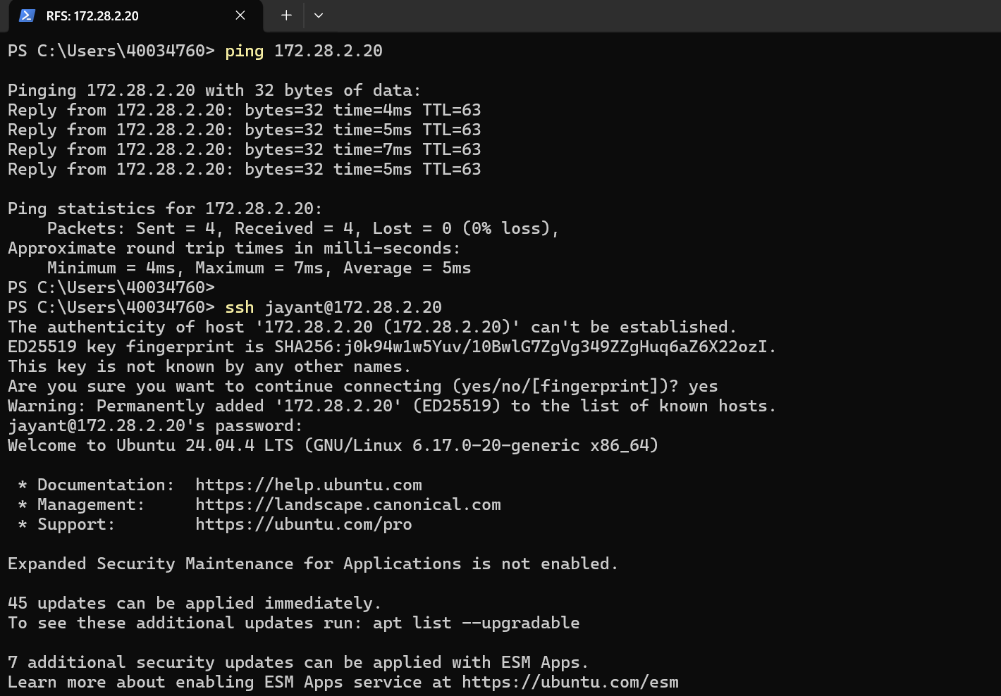
Screenshot — System Overview

Host Information
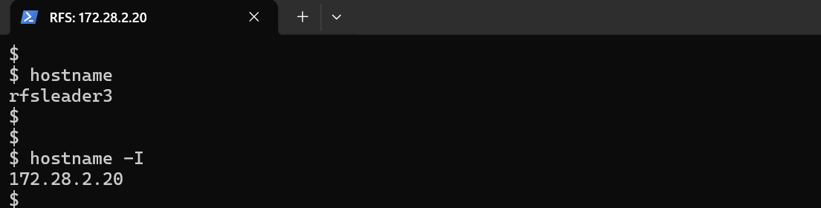
Screenshot — Hostname & IP Address
Hostname | rfsleader3
IP Address | 172.28.2.20
Operating System | Ubuntu 24.04.4 LTS (Noble Numbat)
OS Family | Debian-based Linux

CPU Details
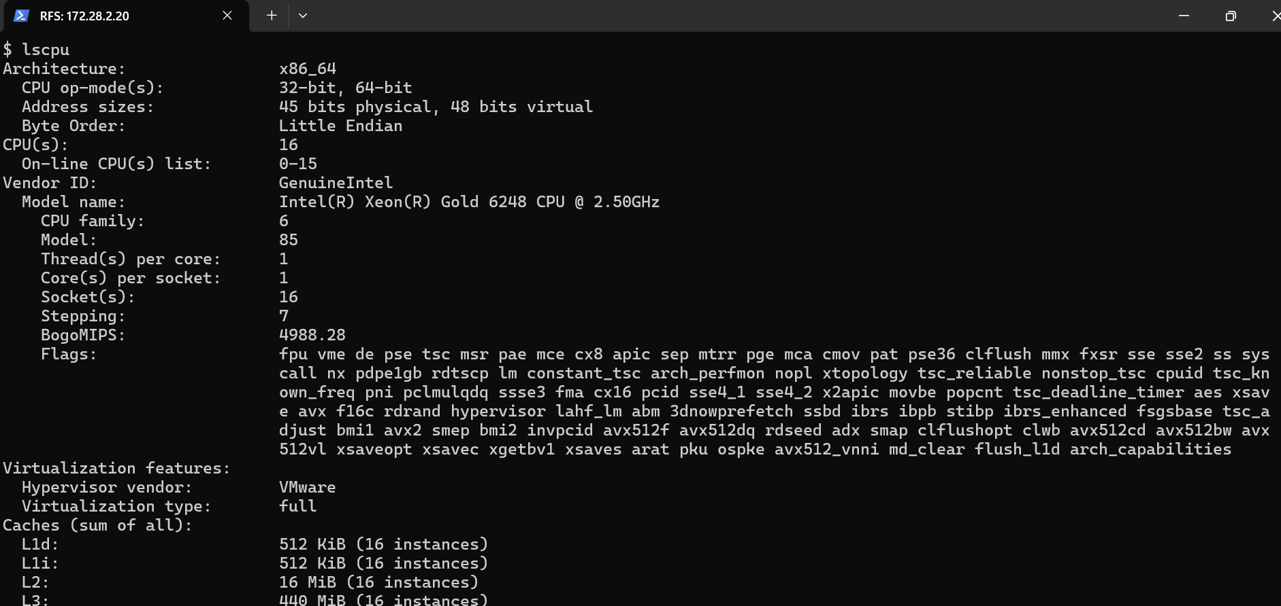
Screenshot — CPU Details
CPU Count | 16
Architecture | x86_64
Processor | Intel(R) Xeon(R) Gold 6248 CPU @ 2.50GHz
Hypervisor | VMware
Virtualization Type | Full

Memory (RAM) Details

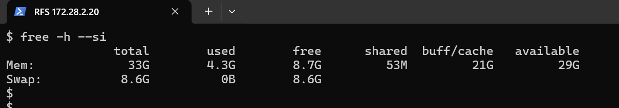
Screenshot — RAM Details
Total RAM | 33 GB
Used RAM | 4.3 GB
Free RAM | 8.7 GB
Available RAM | 29 GB
Buff/Cache | 21 GB
Swap Total | 8.6 GB
Swap Used | 0 B
Swap Free | 8.6 GB

Disk Details
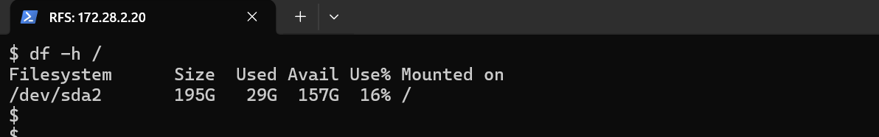
Screenshot — Disk Details
Total Disk Space | 195 G
Used Disk Space | 29 G
Available Disk Space | 157 G
Disk Utilization | 16%
Filesystem | /dev/sda2
Mount Point | /

Operating System Details
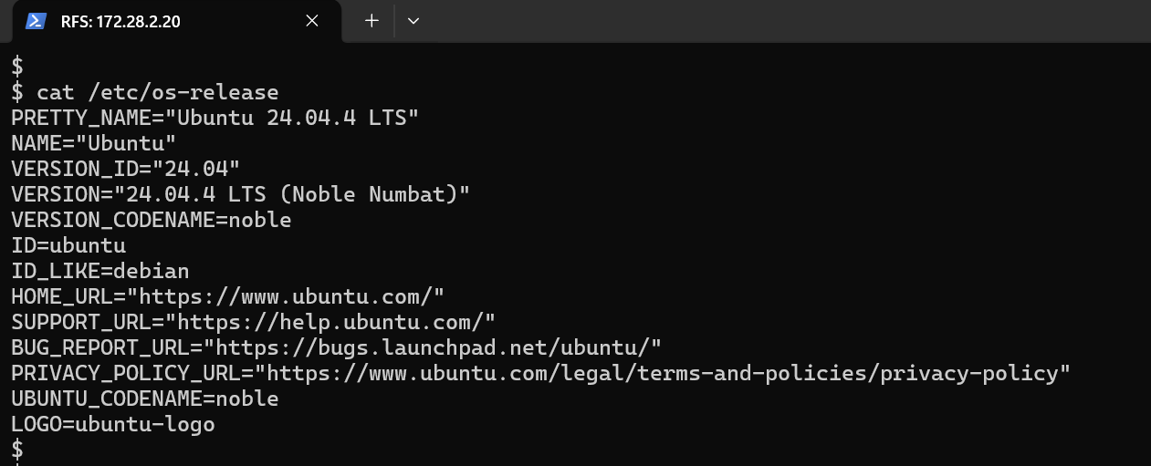
Screenshot — /etc/os-release
Operating System | Ubuntu 24.04.4 LTS
Version | 24.04.4 LTS (Noble Numbat)
Architecture | x86_64
OS Family | Debian-based Linux

System Uptime
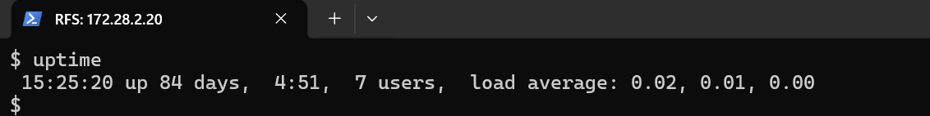
Screenshot — System Uptime
Server Uptime | 84 Days 4 Hours 51 Minutes
Logged-in Users | 7
Load Average (1 min) | 0.02
Load Average (5 min) | 0.01
Load Average (15 min) | 0.00

4. Old Instance — Detailed VM Specifications

4.1 CFS — (172.28.2.150)
Legacy Customer Facing Service
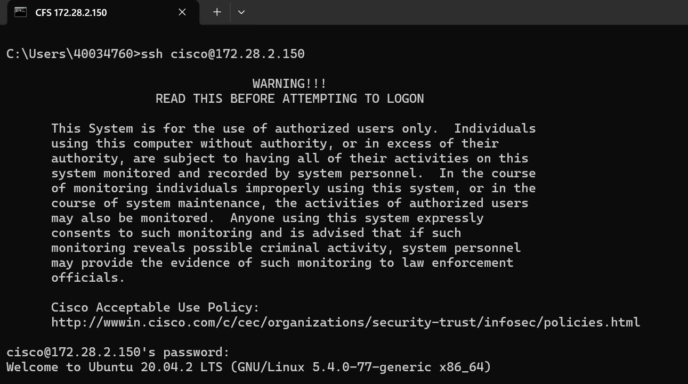
Screenshot — System Overview

Host Information
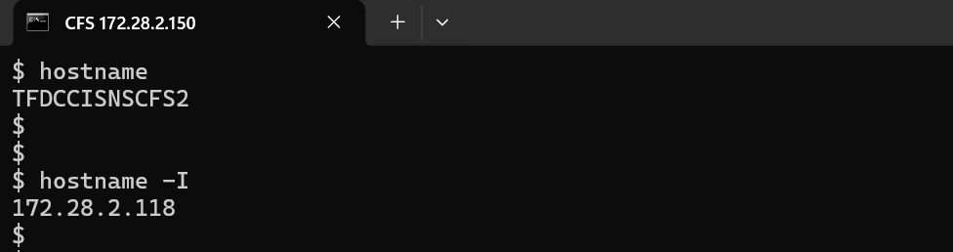
Screenshot — Hostname & IP Address
Hostname | CFS
IP Address | 172.28.2.150
OS Name | Ubuntu
OS Version | 20.04.2 LTS (Focal Fossa)
Codename | focal

CPU Details
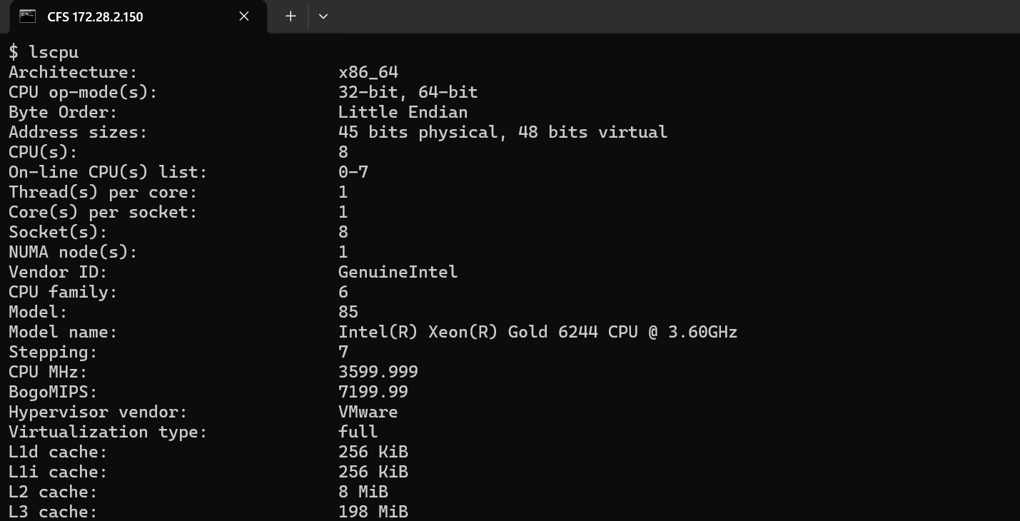
Screenshot — CPU / Virtualization Details
CPU Count | 8
Architecture | x86_64
Processor | Intel(R) Xeon(R) Gold 6244 CPU @ 3.60GHz
Hypervisor | VMware
Virtualization Type | Full

Memory (RAM) Details

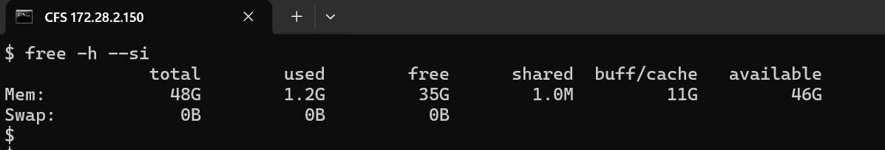
Screenshot — RAM Details
Total RAM | 48 GB
Used RAM | 1.2 GB
Free RAM | 35 GB
Available RAM | 46 GB
Buff/Cache | 11 GB
Swap Total | 0 B
Swap Used | 0 B
Swap Free | 0 B

Disk Details
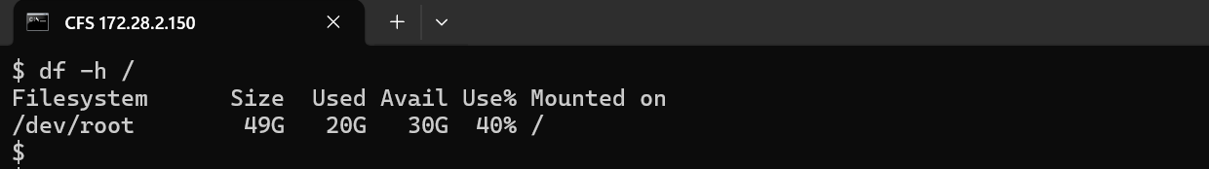
Screenshot — Disk Details
Total Disk | 49 GB
Used Disk | 20 GB
Available Disk | 30 GB
Disk Usage | 40%

Operating System Details
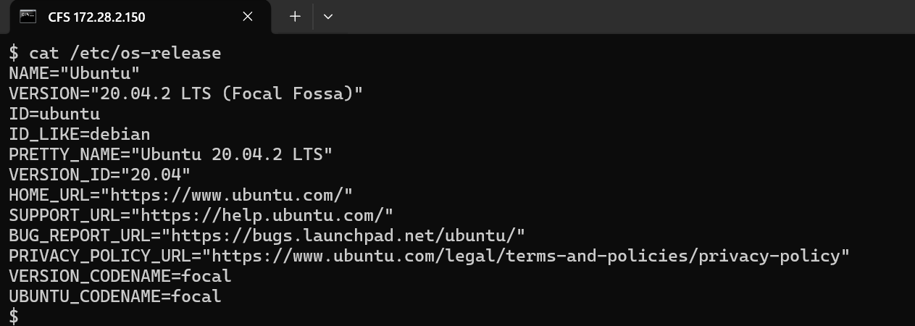
Screenshot — Operating System Details
OS Name | Ubuntu
OS Version | 20.04.2 LTS (Focal Fossa)
Codename | focal

System Uptime
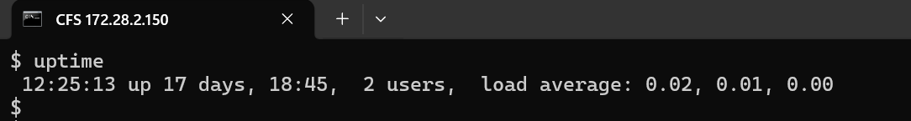
Screenshot — System Uptime
Uptime | 17 Days 18 Hours 45 Minutes

4.2 RFS Primary — TFDCCISNSRFS1 (172.28.2.110 / 172.28.2.133)
Resource Facing Service — Primary node
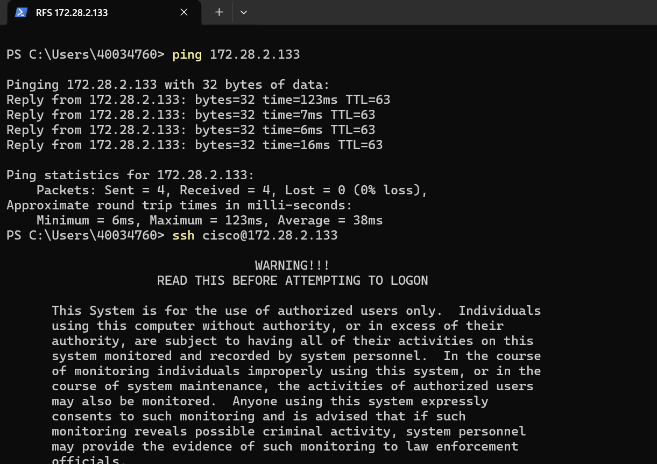
Screenshot — System Overview

Host Information
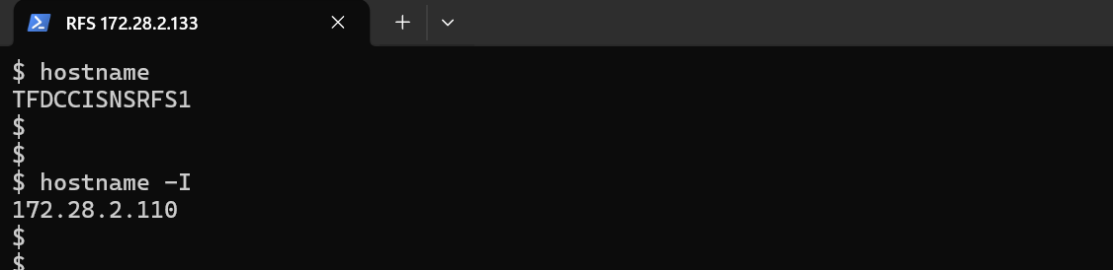
Screenshot — Hostname & IP Address
Hostname | TFDCCISNSRFS1
IP Address | 172.28.2.110 (mgmt) / 172.28.2.133 (RFS service IP)
OS Name | Ubuntu
OS Version | 20.04.4 LTS (Focal Fossa)
Codename | focal

CPU Details
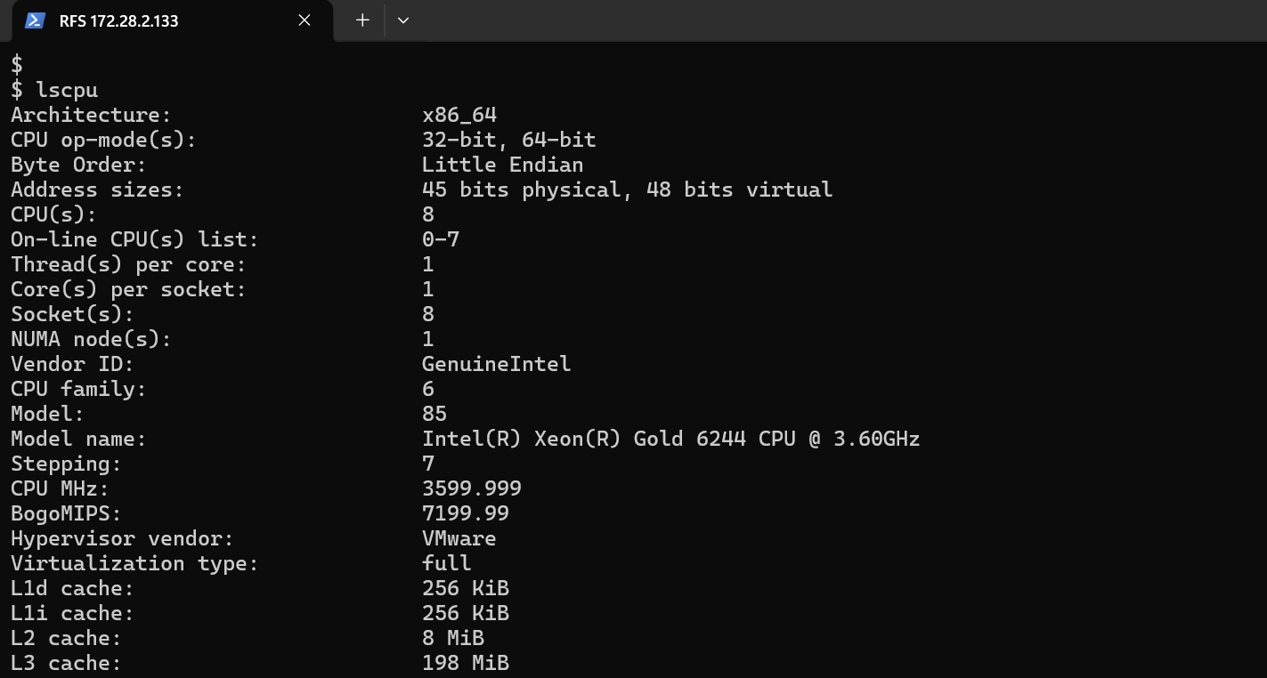
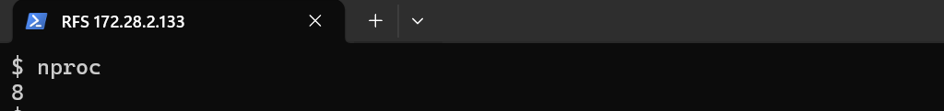
Screenshot — CPU / Virtualization Details
CPU Count | 8
CPU Model | Intel(R) Xeon(R) Gold 6244 CPU @ 3.60GHz
Architecture | x86_64
Hypervisor | VMware
Virtualization Type | Full

Memory (RAM) Details

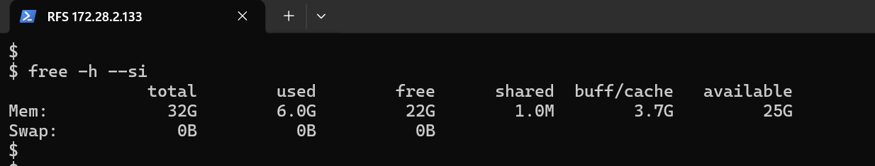
Screenshot — RAM Details
Total RAM | 32 GB
Used RAM | 6.0 GB
Free RAM | 22 GB
Available RAM | 25 GB
Buff/Cache | 3.7 GB
Swap Total | 0 B
Swap Used | 0 B
Swap Free | 0 B

Disk Details
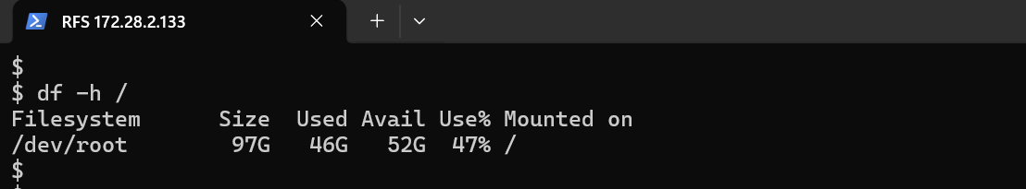
Screenshot — Disk Details
Total Disk | 97 GB
Used Disk | 46 GB
Available Disk | 52 GB
Disk Usage | 47%

Operating System Details
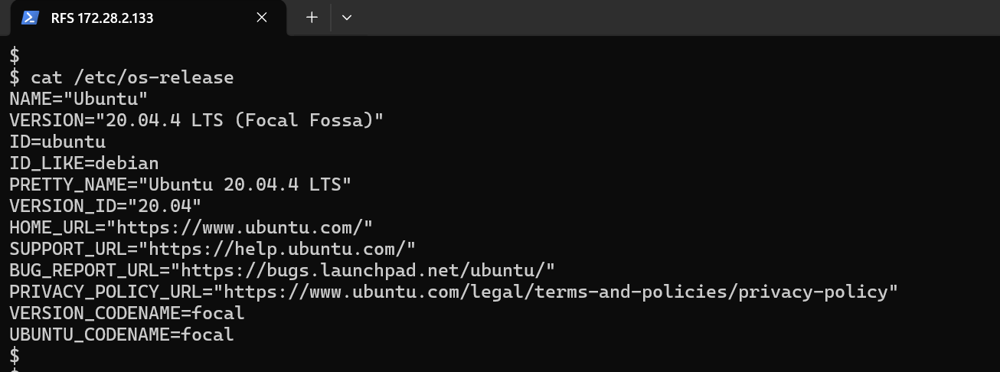
Screenshot — Operating System Details
OS Name | Ubuntu
OS Version | 20.04.4 LTS (Focal Fossa)
Codename | focal

System Uptime
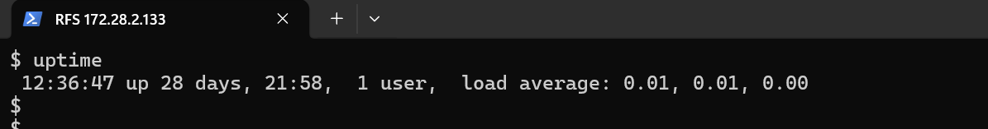
Screenshot — System Uptime
Uptime | 28 Days 21 Hours 58 Minutes
Logged-in Users | 1
Load Average (1 min) | 0.01
Load Average (5 min) | 0.01
Load Average (15 min) | 0.00

4.3 RFS Standby — RFS1-STBY (172.28.2.119)
Resource Facing Service — Standby node
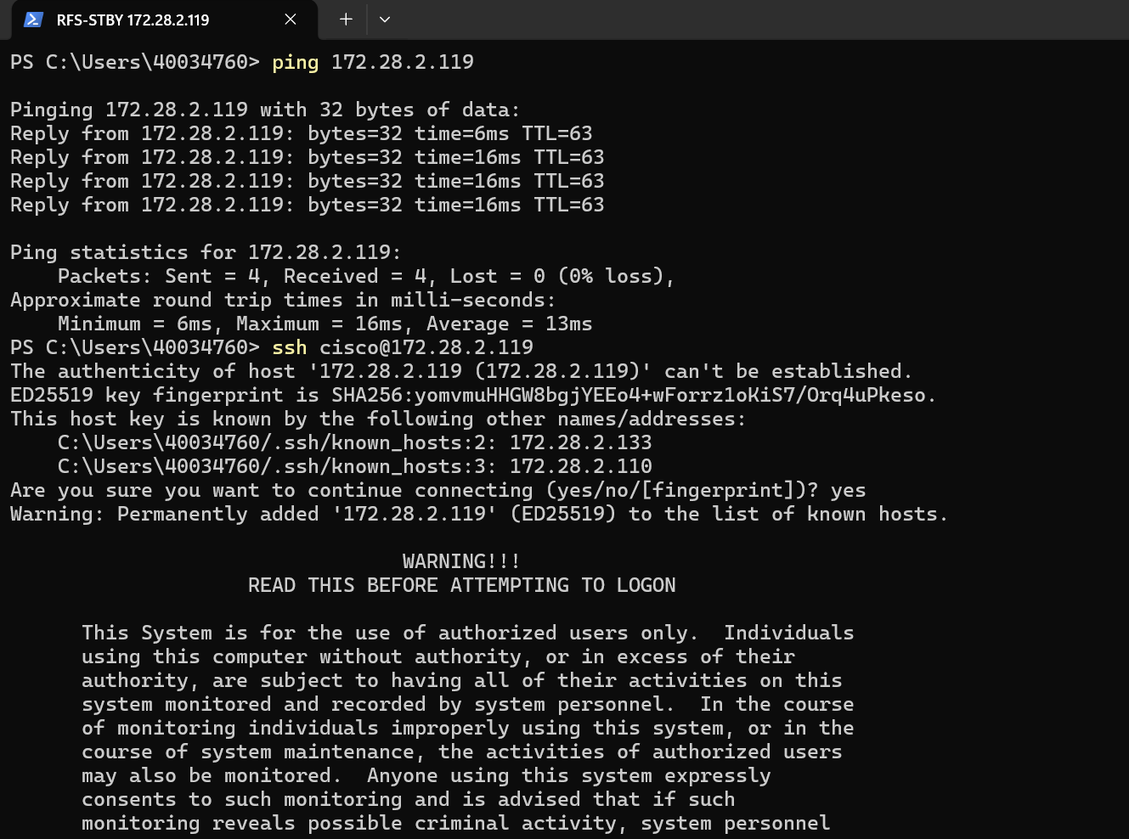
Screenshot — System Overview

Host Information
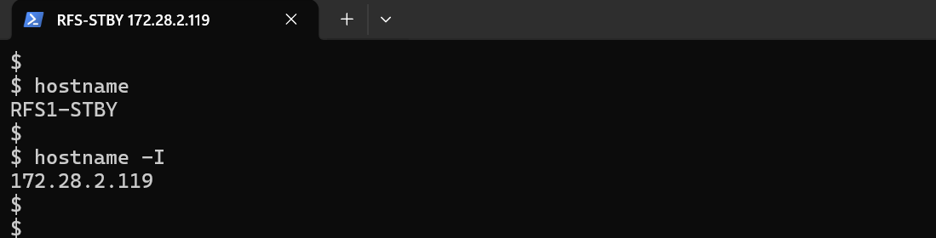
Screenshot — Hostname & IP Address
Hostname | RFS1-STBY
IP Address | 172.28.2.119
OS Name | Ubuntu
OS Version | 20.04.2 LTS (Focal Fossa)
Codename | focal

CPU Details
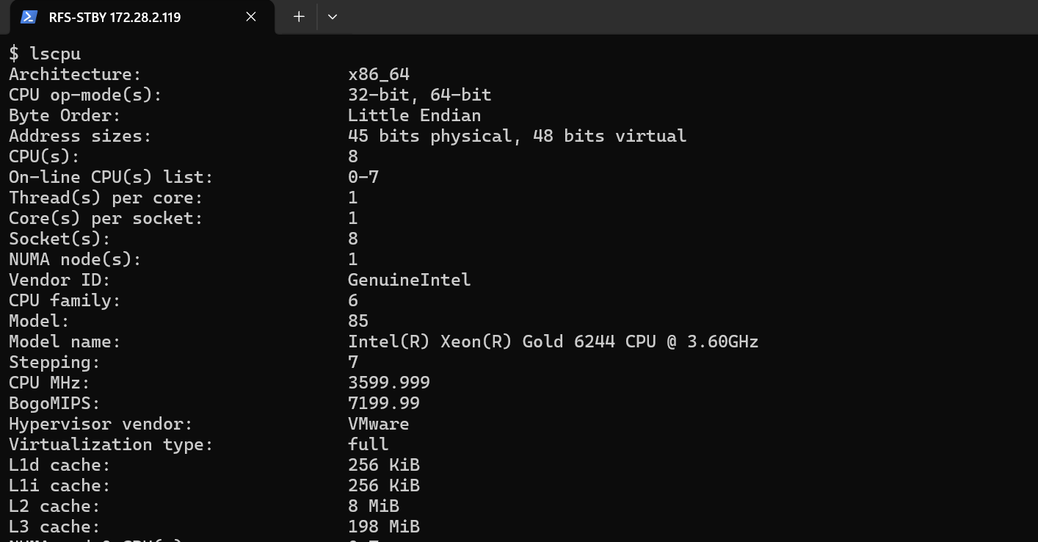
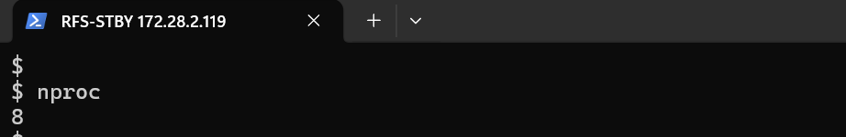
Screenshot — CPU / Virtualization Details
CPU Count | 8
CPU Model | Intel(R) Xeon(R) Gold 6244 CPU @ 3.60GHz
Architecture | x86_64
Hypervisor | VMware
Virtualization Type | Full

Memory (RAM) Details

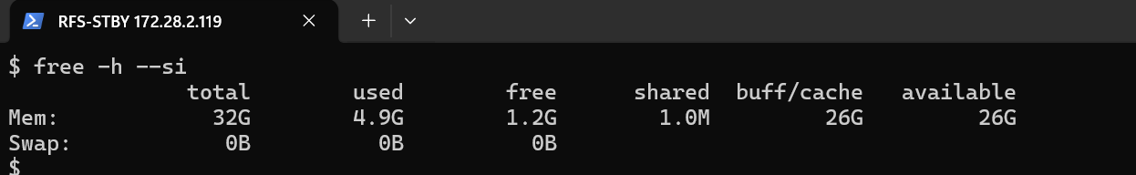
Screenshot — RAM Details
Total RAM | 32 GB
Used RAM | 4.9 GB
Free RAM | 1.2 GB
Available RAM | 26 GB
Buff/Cache | 26 GB
Swap Total | 0 B
Swap Used | 0 B
Swap Free | 0 B

Disk Details
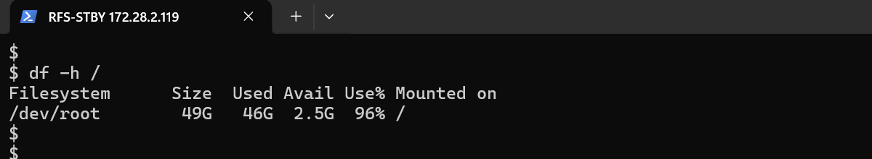
Screenshot — Disk Details
Total Disk | 49 GB
Used Disk | 46 GB
Available Disk | 2.5 GB
Disk Usage | 96%

Operating System Details
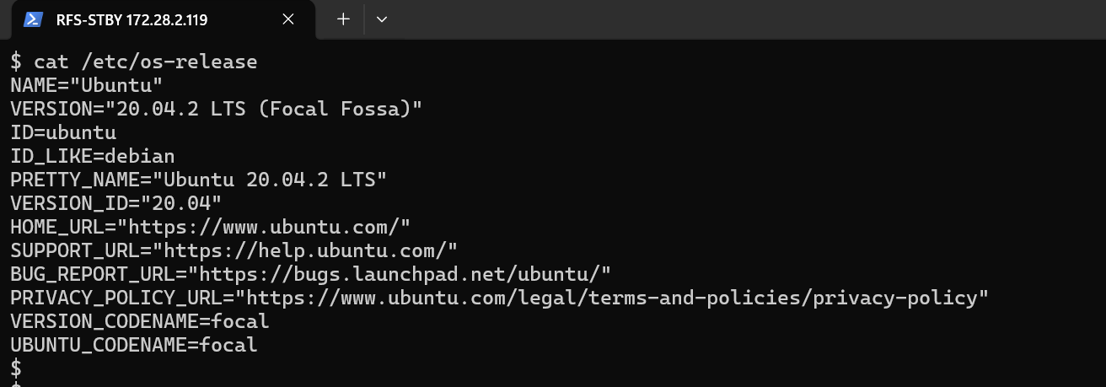
Screenshot — Operating System Details
OS Name | Ubuntu
OS Version | 20.04.2 LTS (Focal Fossa)
Codename | focal

System Uptime
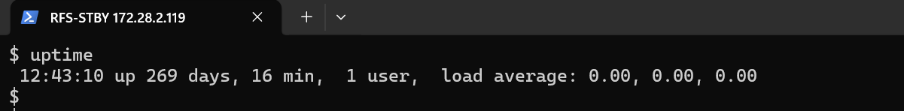
Screenshot — System Uptime
Uptime | 269 Days 16 Minutes
Logged-in Users | 1
Load Average (1 min) | 0.00
Load Average (5 min) | 0.00
Load Average (15 min) | 0.00

5. Appendix — Consolidated Data Sheet
Hostname | IP Address | CPU | RAM (Total) | Disk (Total) | Disk Util | OS
cfsleader | 172.28.2.17 | 8 | 16 GB | 97 G | 29% | Ubuntu 24.04.4
rfsleader1 | 172.28.2.18 | 16 | 33 GB | 195 G | 30% | Ubuntu 24.04.4
rfsleader2 | 172.28.2.19 | 16 | 33 GB | 195 G | 17% | Ubuntu 24.04.4
rfsleader3 | 172.28.2.20 | 16 | 33 GB | 195 G | 16% | Ubuntu 24.04.4
CFS | 172.28.2.150 | 8 | 48 GB | 49 GB | 40% | Ubuntu 20.04.2
TFDCCISNSRFS1 | 172.28.2.110/.133 | 8 | 32 GB | 97 GB | 47% | Ubuntu 20.04.4
RFS1-STBY | 172.28.2.119 | 8 | 32 GB | 49 GB | 96% | Ubuntu 20.04.2

